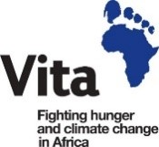
Final Report to the Staff of HSE (Cork and Kerry) Association for the Relief of Poverty (SHARP HSE)
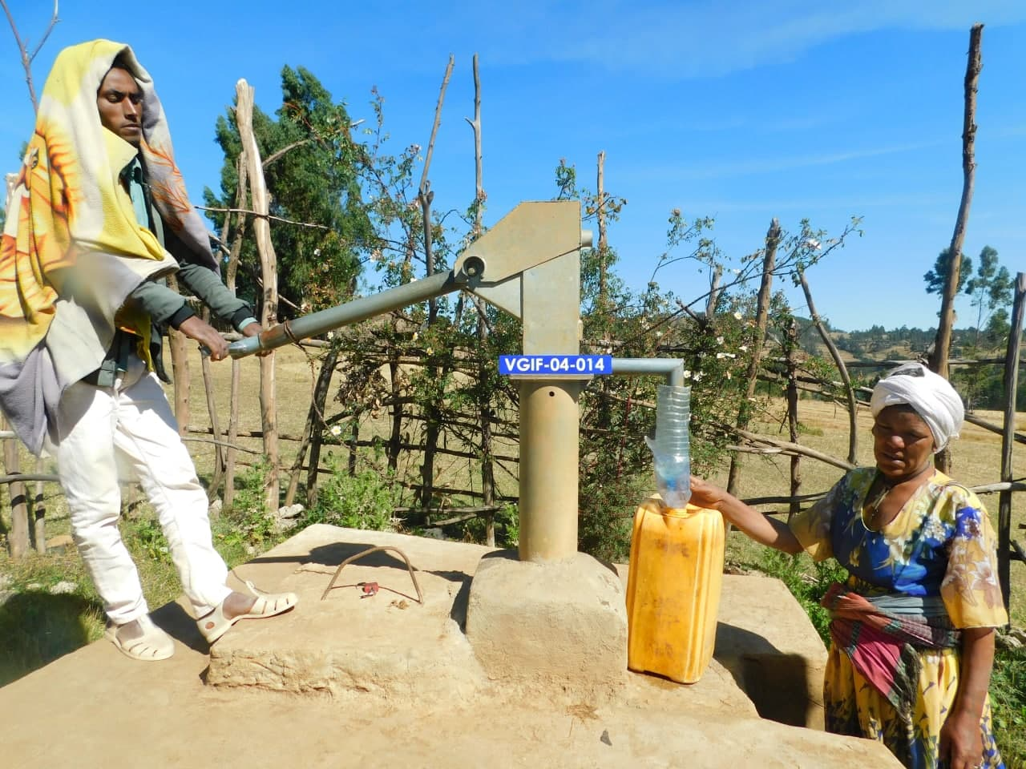
Community members collecting clean water from their village water pump, which was recently maintained with support from SHARP HSE
Organisation | Vita
Project title | Sustainable water maintenance and community hygiene for disease prevention in South Gonder, Ethiopia
Country | Ethiopia
Amount received | €7,021
Address | Equity House, 16-17 Upper Ormond Quay, Dublin 7
Phone | (01) 873 4303
Contact person | Ciara Feehely
Report date | 16 March 2022

Impact
3,500 people with access to clean water :
100% of households covered
Improved household hygiene
Reduced time-burden on women and girls
Carbon emissions reduced and natural environment protected

Project Overview
The SHARP HSE-supported project delivered sustained access to safe water to 3,500 people in seven rural villages and improved their health outcomes. The project used the heightened awareness of the role of hygiene in disease prevention and the widespread motivation to stop COVID-19 transmission to improve community hygiene practices and lower the risk of disease and infection.
The project was managed by a team of local, experienced staff and led by the Project Coordinator, based in Vita’s regional office for Bahir Dar town in Amhara Region. They were supported by Vita community development field workers in South Gonder Zone. All programme quality aspects, particularly the monitoring and evaluation of the project, were and continue to be supported by Vita’s Programme Quality Officer in Dublin. Monitoring visits were built into the programme quality, and local community health workers provided specialist advice to augment our data gathering around health impacts.
The total project cost was €7,428, of which SHARP generously contributed €7,021.
Project objective:
The objective of this project was to improve the health status, prevent COVID-19 transmission and reduce incidence of water-related disease and infection amongst rural communities in South Gonder Zone by ensuring continued access to safe water and by improving community-led hygiene management. The project realised this objective over the past year and the health of 3,500 individuals in seven rural villages was protected and improved.
Vita achieved this by capitalising on the unique opportunity presented by the COVID-19 pandemic and increased community desire to lower the risk of COVID-19 transmission. The project used this heightened interest to strengthen the link between safe water, household hygiene and health in rural communities in the north-west of Ethiopia. The project carried out maintenance work on seven water points (each water point approximately serving 500 people) and trained community members in good hygiene practice.
Project Location
The project was implemented in seven rural villages located in South Gonder Zone, Amhara Region, situated in the north-west of Ethiopia. Please see the project location in the map below.
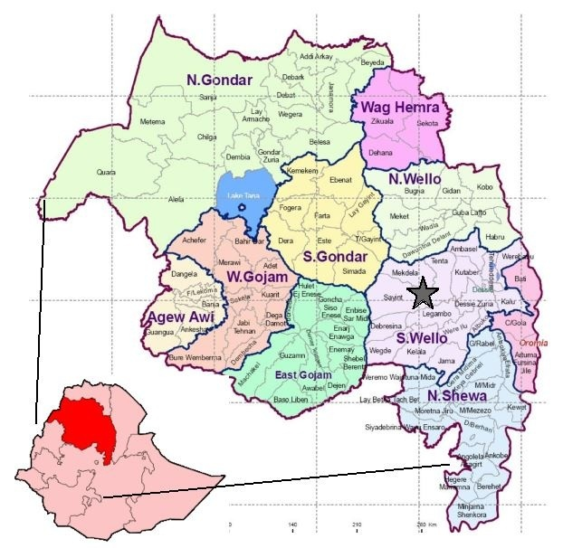
Figure 1: Location of South Gonder Zone, Amhara region, Ethiopia

Beneficiaries
3,500 individuals benefitted from the maintenance of seven water points (each water point approximately serving 500 people) and from the practical training in good hygiene practice and how to minimise the risk of contracting water-related diseases and COVID-19.

Key Activities and Results
(1) Spare parts for maintenance of seven water points purchased: The project carried out a detailed maintenance assessment of each water point. This assessment identified the types of water spare parts repaired to keep the water points fully functional. Vita will purchase the required parts and materials identified as per Vita procurement procedures. These included pump heads, chains, valves, cylinders and pipes.
(2) Maintenance of seven water points: The physical repair work was carried out on seven water points by external water technicians. Vita hired construction specialists to carry out the necessary masonry work. All maintenance was carried out in close collaboration with local government experts and the communities.

(3) Water quality tests conducted on seven water points: Once maintenance work was completed, the quality of water was tested and purification treatment was carried out where necessary. Regular water quality testing was carried out to ensure that water is still clean and safe for drinking. All testing and treatment is in line with the parameters of the national water quality standards.
(4) Seven community Water User Association committees (49 committee members) participated in community and household hygiene, sanitation and disease prevention ToT training (Training of Trainers): This training had a particular focus on COVID-19 prevention, as well as good personal and household hygiene practices, and how to maintain water safety once it has been collected from the water point (safe water chain process). The trained committee members then cascaded their learning in their respective villages to approximately 3,500 community members.
(5) Sustainable water scheme management refresher training for seven Water User Association Committees. The 49 committee members attended refresher training, which covered governance procedures and processes in place for the Water User Association Committees and committee members’ roles and responsibilities in relation to the water point. It followed up on previous training on carrying out minor repairs to the water points without the need for external assistance. This is helping to safeguard sustainable, continuous access to clean water all year round.
(6) A tailored monitoring and evaluation system was established: Vita’s existing monitoring and evaluation system was strengthened for successful implementation of the project.
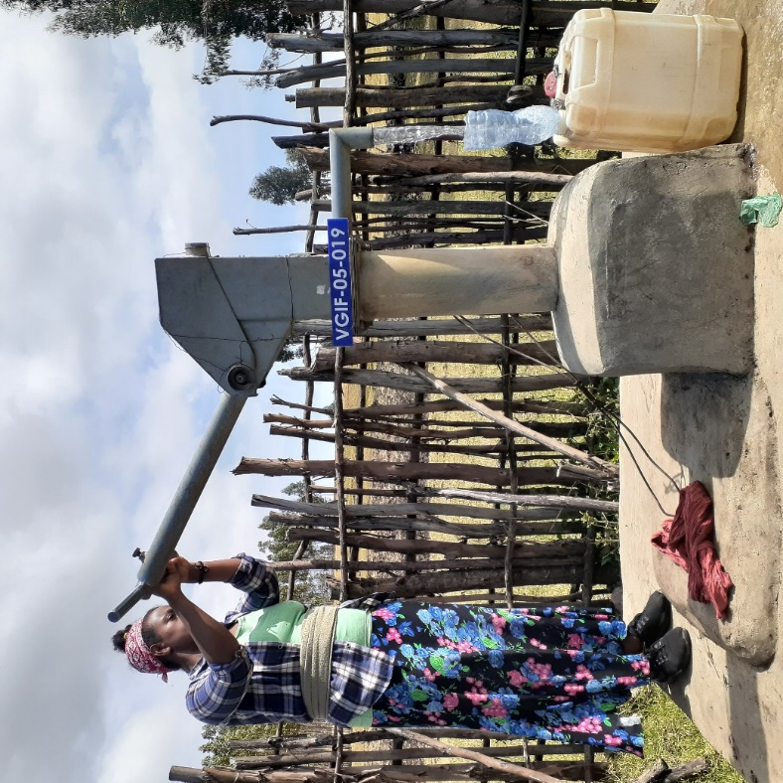
Project Impact
By ensuring the full functionality of community water points and bolstering community hygiene knowledge and practice, the project delivered the following benefits:
- 100% of households in the seven villages are accessing sufficient safe water for all household needs: Safe water is accessible close to people’s homes. The maximum water time it takes to fetch is a 30-minute round trip from their homestead.
- 3,500 community members are sustaining good health outcomes: Before their local water points were rehabilitated, these communities had been collecting water from contaminated, unsafe sources, greatly increasing exposure to water-related disease and infection – a major contributor to deaths of children under five years of age in Ethiopia. By carrying out the required maintenance work on seven water points, this project enabled 700 families prevented people from returning to their former, unsafe water sources. Continued access to clean water helped 3,500 people retain the low incidence of water-borne disease and infection among households. An evaluation that included the seven project villages found that reported prevalence of diarrhoea among communities (including all household members) where water points have been repaired and maintained decreased by 82% within the previous six months.
- Improved household hygiene: Vita’s experience of previous water point repair projects indicates that the benefits of having sufficient water for household hygiene needs not only contributes to improved health – maintaining a neat and tidy appearance is a cornerstone of pride and dignity in any context, and being able to ensure a clean and neat appearance at school, functions and in business is recognized by beneficiaries as a major benefit of having access to safe water in their community. At the time of evaluation, 70% of households reported consistent use of handwashing at critical times and had soap and water for at handwashing stations (i.e. outside latrines) at time of the monitoring visit. This was an increase from 38% of households 6 months earlier.
- Reduced time-burden on women and girls: In Ethiopia, the task of collecting water for the household falls overwhelmingly to women and girls, often spending several hours per day travelling long distances with heavy loads. The water points maintained by this project are a maximum of 15-minutes walking distance from the furthest home. This provides the community with access to safe water within a 30-minute round trip per collection. This frees up time to be spent on other activities – such as income generation, school attendance, civic participation or simply relaxing. Maximum safe water collection time now takes a maximum of 30 minutes per round trip, compared to a maximum 4-hour round trip pre-project.
- Carbon emissions reduced and natural environment protected: In scenarios where community members are collecting water for consumption from unsafe, unprotected sources such as ponds and rivers, it is necessary to purify their water before drinking – in rural Ethiopia, this overwhelmingly means boiling water. By maintaining the seven water points this project has removed this need. This has saved thousands of tonnes of carbon and methane emissions from being released into the atmosphere. It has also decreased air pollution in the household and protected women and children from being exposed to dangerous concentrations of particulate matter. Finally, it has saved many tonnes of firewood from cut and burned to boil water. This is helping to ensure that forest resources can be managed more sustainably. Ensuring continued access to clean water is helping to preserve the benefits that trees provide for the livelihoods of rural committees.

Impact Case Studies
The following case study aptly demonstrates the impact of the project as the beneficiary communities perceive them:
W/ro Enanye Kassaye, a 35- year old mother of three remembers her family’s struggles before the water point in her village was repaired and talks about the impact that accessible clean water is having:
"My daughter used to miss school as she accompanied me to fetch water, to help carry it,” says Enanye. “Now this repaired water point has changed my daughter’s life and brought a sense of peace and happiness. She can now read and is doing her homework. In this village, the well-maintained hand pump means girls will now focus on school again."
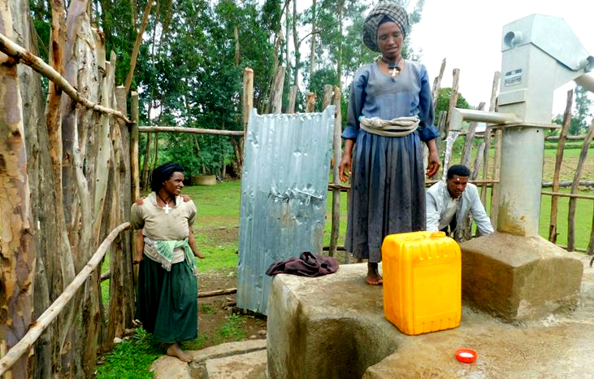
Enanye fetching clean water near her home

Financial Utilisation
Project total cost was €7,454, of which SHARP generously funded €7,021. Vita covered the balance, which was €433.
Expenditure by categories
Exchange rate €1= 45 ETB
Ends

Vita PGII External Evaluation, December 2021
Vita PGII External Evaluation

