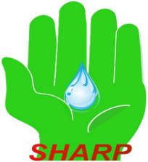
Authorisation Form

Staff of the Health Service Executive (Cork & Kerry) Association for the Relief of Poverty (SHARP)

If you would like to join the association or to change your subscription, please complete and sign this Authorisation Form and return by email to salaries@hse.ie
copied to: sharptreasurer1@gmail.com and sharpsecretary1@gmail.com
or post to: Administration Officer, Voluntary Deductions, Payroll Section, HSE South, Áras Sláinte, Dennehys Cross, Cork.

You can become a member of SHARP from as little as €1 per pay period. While any donation is welcome it should be noted that a donation of €21 per month (i.e. > €250/year) will allow SHARP to claim a tax refund amounting to 45% of your donation.

Authorisation

Name: ________________________________________

Email Address: ________________________________________

Work Location: ________________________________________

Job Title: ________________________________________

Group & Personnel Number: ___________________________

I hereby authorise the HSE to deduct the sum of € _________ per pay period* and lodge it to the credit of the Staff of the HSE (Cork & Kerry) Association for the relief of poverty (SHARP)
* Pay Period refers to the frequency of pay, in other words how often you receive a payslip whether fortnightly or monthly.

I authorise the HSE to share my contact details with the Management Committee of SHARP for the sole purpose of communicating with me in relation to SHARP related matters including notice of Annual General Meetings, Project Reports, and Charitable Tax Refunds

Signature _____________________________________ Date ______________

